

Practices for Secure Software Report

Table of Contents
Document Revision History 3
Client 3
Instructions 3
Developer 4
1. Algorithm Cipher 4
2. Certificate Generation 4
3. Deploy Cipher 4
4. Secure Communications 4
5. Secondary Testing 4
6. Functional Testing 4
7. Summary 4
8. Industry Standard Best Practices 4

Document Revision History

Version | Date | Author | Comments
1.0 | 12/14/2025 | Anthony Arnett | Initial Version

Client



Instructions

Submit this completed practices for secure software report. Replace the bracketed text with the relevant information. You must document your process for writing secure communications and refactoring code that complies with software security testing protocols.

- Respond to the steps outlined below and include your findings.
- Respond using your own words. You may also choose to include images or supporting materials. If you include them, make certain to insert them in all the relevant locations in the document.
- Refer to the Project Two Guidelines and Rubric for more detailed instructions about each section of the template.

Developer
Anthony Arnett

Algorithm Cipher

I recommend using SHA-256 as the checksum algorithm paired with TLS for secure transport. SHA-256 is considered secure for integrity checks and is industry standard. TLS protects data in transit, SHA-256 checksum helps validate file/data integrity. SHA-256 outputs 256 bits, making it harder to brute-force collisions. Older algorithms like MD5 and SHA-1 are considered broken/weak for collision resistance.

Certificate Generation
Insert a screenshot below of the CER file.

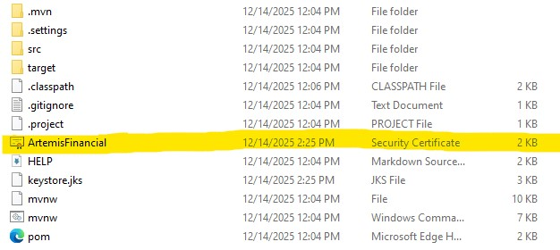

Deploy Cipher
Insert a screenshot below of the checksum verification.

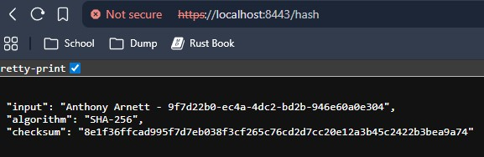

Secure Communications
Insert a screenshot below of the web browser that shows a secure webpage.



Secondary Testing
Insert screenshots below of the refactored code executed without errors and the dependency-check report.

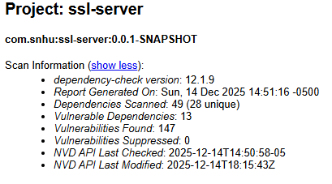
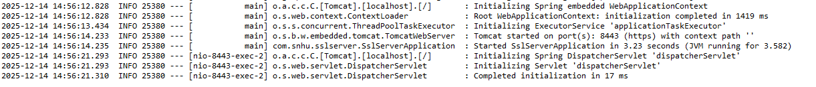

Functional Testing
Insert a screenshot below of the refactored code executed without errors.

Summary

I followed basic vulnerability assessment workflow by reviewing the existing application and confirmed it had placeholder SSL settings. I then refactored the application to add a SHA-256 checksum feature and enabled HTTPS using a self-signed certificate generated with Java Keytool. After adding these changes, I verified the application ran successfully and produced a consistent checksum output for a unique data string that included my name. I ran the OWASP dependency-check to confirm that refactoring did not add any new vulnerable dependencies and documented results with screenshots.

Industry Standard Best Practices

I applied industry standard secure coding practices by using HTTPS to protect data in transit and by implementing checksum verification using SHA-256, a modern cryptographic hash algorithm. I did not use outdated hashing methods like MD5 or SHA-1 and used Java’s built-in security libraries instead of adding additional third-party cryptography dependencies. To maintain the existing security posture, I kept changes limited to the required functionality, verified the application ran without errors, and performed secondary static testing with OWASP dependency-check to confirm no new vulnerable dependencies were introduced. Applying these best practices improves Artemis Financial’s overall well-being by reducing the risk of data exposure, strengthening integrity checks for transferred data, and supporting customer trust and compliance expectations.

